Name: Astha Arpit Bhatt

Enroll: 196140316006

Practical-4

Aim: Develop an applet that displays the position of the mouse at the upper left corner of the applet when it is dragged or moved. Draw a 10x10 pixel rectangle filed with black at the current mouse position

Code:

import java.applet.\*;

import java.awt.\*;

import java.awt.event.\*;

/\*<applet code="pra4.class" height=500 width=500></applet>\*/

public class pra4 extends Applet implements MouseMotionListener

{

static int x,y;

public void init()

{

addMouseMotionListener(this);

}

public void paint(Graphics g)

{

g.drawString("X = " +x+ " ,Y = " +y,15,15);

g.fillRect(x,y,10,10);

}

public void mouseMoved(MouseEvent e)

{

x = e.getX();

y = e.getY();

repaint();

}

public void mouseDragged(MouseEvent e)

{

x = e.getX();

y = e.getY();

repaint();

}

public void mouseExited(MouseEvent e)

{

}

public void mouseEntered(MouseEvent e)

{

}

public void mouseClicked(MouseEvent e)

{

}

}

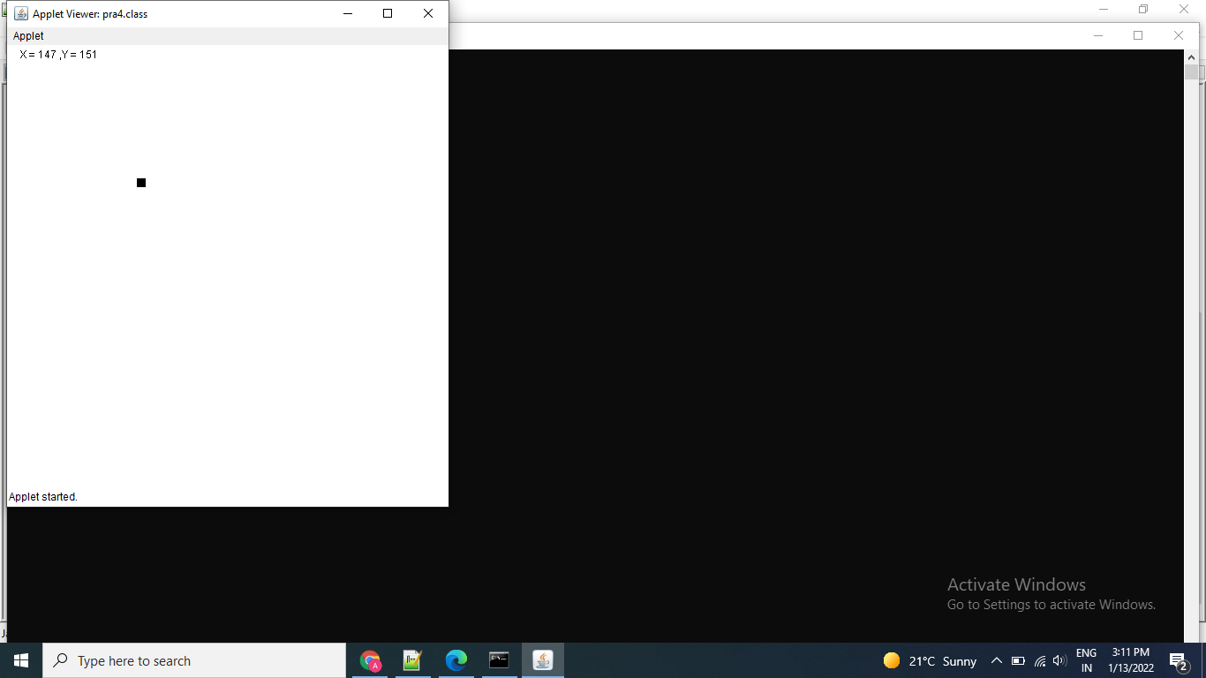

Exercise :

Develop an applet that draws an oval filled with blue color at current mouse position

Code:

import java.applet.\*;

import java.awt.\*;

import java.awt.event.\*;

/\*<applet code="pra4e1.class" height=500 width=500></applet>\*/

public class pra4e1 extends Applet implements MouseMotionListener

{

static int x,y;

public void init()

{

addMouseMotionListener(this);

}

public void paint(Graphics g)

{

g.drawString("X = " +x+ " ,Y = " +y,15,15);

g.setColor(Color.blue);

g.fillOval(x,y,20,25);

}

public void mouseMoved(MouseEvent e)

{

x = e.getX();

y = e.getY();

repaint();

}

public void mouseDragged(MouseEvent e)

{

x = e.getX();

y = e.getY();

repaint();

}

public void mouseExited(MouseEvent e)

{

}

public void mouseEntered(MouseEvent e)

{

}

public void mouseClicked(MouseEvent e)

{

}

}

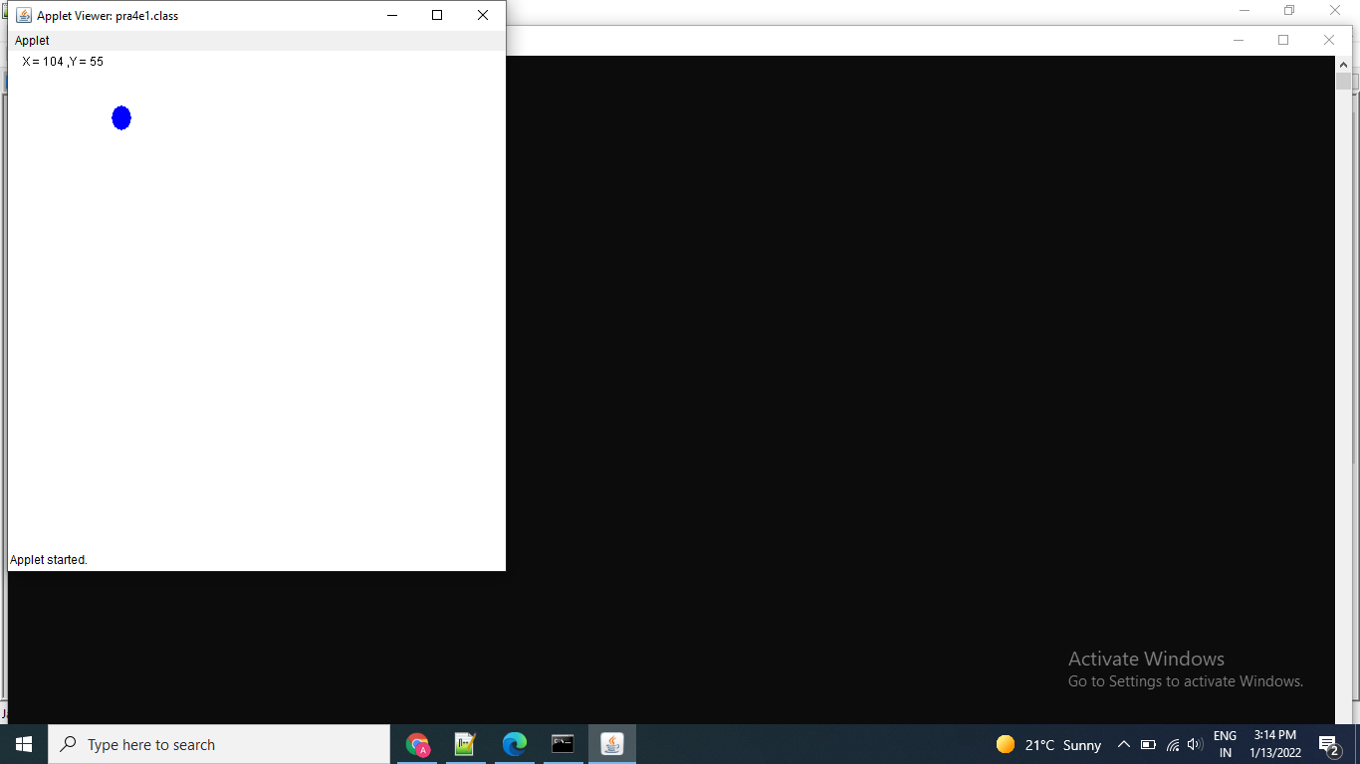

Thanks mam!!